Sample Retrieval Competition
(rule version 20190115.00)

Objective: The robot will start at a home base and search an area or room for five specific objects lying on the floor. After finding an object the robot will pick it up and return it to the home base. The five objects are: a baseball, a children’s block (cube), an empty soda can that has not been modified, a small doll (6 to 12”), and a RC car wheel with tire. Pictures of the items are included in this ruleset. The items must be retrieved within a set time period. The more items retrieved the higher the robot’s score. There may also be additional items on the floor that if retrieved, do not add to the robot’s score.

Robot: Competing robots must run autonomously but are not required to be self-contained. All sensors must be mounted on the robot. Robot length and width is limited to 18x18 inches and may not become larger than this size at any stage of the contest. Maximum robot weight is 30 pounds.

Self-Contained Definition: Self-contained means that all computing power used to run the robot is carried on the robot platform.

Run Definition: A run starts when the robot is placed in the home base area of the arena, given a signal from the judge, and moves. If the robot fails to move, the competitor can remove the robot and try again at the end of the round. If the robot doesn’t move when given this 2nd chance, its run is forfeited. The run ends whenever the robot completes the objectives, or malfunctions after moving, or 5 minutes has elapsed. Each robot is allowed 1 run per contest round.

Round Definition: A round consists of a single run by each competing robot. The competition consists of 3 rounds.

Play: At the start of the competition, the robot may be placed anywhere in the home base. The robot may be turned to any angle when initially placed.

The run’s timer will start when the robot starts to move.

The robot must search the arena and locate the desired objects and return them to the home base area.

If the robot disturbs the cone located in the home base, it will not be returned to its original position during the run.

If any part of an object is within the home base area it is considered retrieved.

Beacons or other navigational aids either in or outside of the arena are not allowed.

Course: The arena consists of a search area and a home base. The search area should be as large as possible up to room size. Obstacles in the search area should be left in place. The home base is a 30X30 inch square outlined in blue painter tape with a small fluorescent orange cone (6 to 9 inches in height) located in the center. Both the home base and the objects are placed in the search area by the judge. Object locations will be marked with a small piece of painter tape, so runs between competitors are the same. The judge may also add decoy objects to the search area, that do not score a point if retrieved. These decoys may be a similar shape or color as the true objects. Example decoys might be a soccer ball or a small box. The judge is not required to add decoy objects.

Objects:

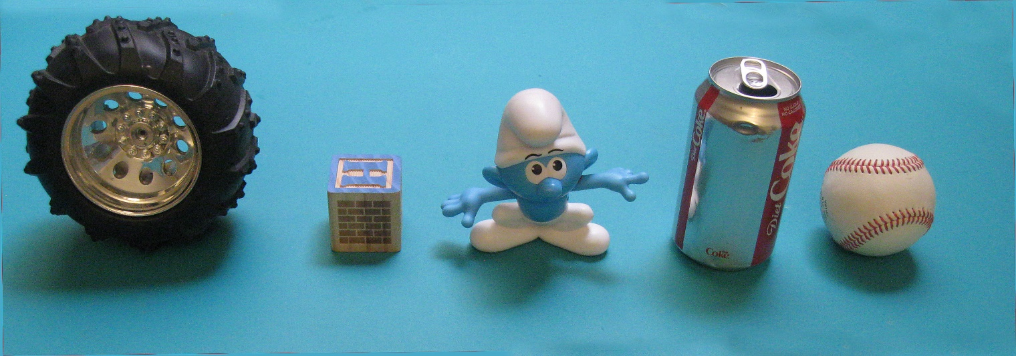
Note: The block may not be the letter H.

Images of the objects for learning can be found using Google image and searching for: RC wheel, wooden block letters, Smurf action figure, diet coke can, and baseball. The actual objects will be available at DPRG’s Robot Builders Night Out (RBNO) held at the Dallas Maker Space every Tuesday before the event between 7 and 10 PM.

Scoring: A robot’s run score is the sum of the number of objects retrieved within the time limit. The top three scores will be awarded 1st, 2nd, and 3rd place in the competition. If multiple perfect scores are achieved, the fastest run time will be used to determine the winner. If no perfect score is achieved and there is a tie in the number of objects retrieved, the tied contestants will all place their robots in the home base at the same time and try to retrieve an object. The judge may adjust the object locations before this run. The robot that retrieves an object first gets the highest placement. The other robots will be ranked on the speed that they return an object. If some robots fail to retrieve an object, they will determine their rank between themselves by coin toss. Time limit for this run is 5 minutes. If after 5 minutes no robot retrieves an object, the ranking of all robots at that level will be considered the same and they will select prizes last with the 2nd place prize winners. No place or prize will be awarded to a robot that doesn’t at least retrieve one object during the competition.

A perfect score is 5.

Judging: One or more judges will referee the contest. They will ensure the rules are followed and impose scoring penalties or remove a robot from competition if the robot is operating in an unsafe manner or not complying with the rules. The decisions of the judges are final.

